Meal Plan and Grocery Shopping

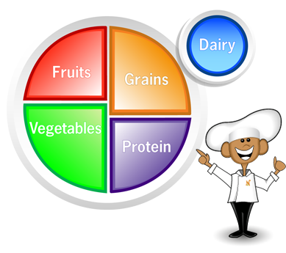

- Type you meal plan in the table on page two. Make sure that each meal contains the following:
  - Fruit, Vegetable, Grain, Protein, Dairy
  - Variety of colors
  - Variety of textures
  - Variety of temperatures

- Prepare your shopping list for the three meals. Type your list in the table on page three.

Meal Plan

{Your Name} Meal Plan
 | Breakfast | Lunch | Dinner/Supper
Day 1
($20 limit)
Day 2
Day 3

Shopping List

Item | Cost | Store

