Microsoft Word 2019
Lesson 3 Application

I Can…
Part A – Line Spacing |  | Part A – Tabs |  | Part B – Tables |  |  | Part D– Columns
☐ | Paragraph Spacing | ☐ | Set Left Tabs | ☐ | Delete/Insert Table | ☐ | Set Columns
☐ | Double/Single Spacing | ☐ | Right Tabs | ☐ | Convert to table/Text | ☐ | Column breaks
☐ | Custom Spacing | ☐ | Center Tabs | ☐ | Merge/Split | ☐ | Column Settings
☐ | Indentation | ☐ | Decimal Tabs | ☐ | Adding/Deleting Cells | ☐ | Unequal Columns
 |  | ☐ | Clear Tabs | ☐ | Staggered cells | ☐ | Columns w/ Text Boxes
 |  | ☐ | Tabs by Ruler | ☐ | Distribute Columns
 |  | ☐ | Dot Leaders | ☐ | Text Directions
 |  | ☐ | End, Delete, Enter | ☐ | Table Styles

Instructions:

☐ |  | Open the starter assignment from the Lesson 3 folder.
☐ |  | Line Spacing – Select the entire document (CTRL+A) and change the line spacing to 0 on left, right, before, and after. After is probably set to 8.
☐ |  | Margins – Change the margins narrow
☐ |  | Orientation – Change the orientation to Landscape
☐ |  | Page Border – Add an art page border. Select the any pattern background (please don’t pick the cupcakes!) and make it size 5pt and red.
☐ |  | Save – Save the file now before you move on to the next part. Save it as Lesson 3 Application – your initials, adding your own initials after the name.
☐ |  | Footer – Insert a three column footer. Type your name in the first column. Type your class period in the middle.
☐ |  | Filename – in the third column of the footer, add the file name.
☐ |  | Footer from Bottom - Move the footer on the bottom to .2—it should be just barely below the border. Close Footer.
☐ |  | Font – Center “Redford City.” Choose a new font—something basic and easily readable—you will be using that font again and again throughout the document. Change the size to 22.
☐ |  | Word Art – Press enter once, then clear formatting so that the next line is no longer in size 22. Enter again. Add Word Art that says “200th Anniversary Celebration!”
☐ |  | Keep the font size at 36, but choose another, fancier font (not the one you picked before.) Change the color to black. (Design tip: It looks better if you pick two very different fonts—one more blocky and the other more cursivey. But it’s up to you!)
☐ |  | Move the WordArt just under the Redford City. Both lines should stay above the 1” mark on the left side ruler. It will be tight getting everything to fit on one page, so be exact.
☐ |  | Paragraph Formatting – Select the first paragraph that begins with “Come and join us” and ends with “Once-in-a-lifetime event!”
☐ |  | Change the border to dotted and the background to deep red. The font should automatically change to white. Italicize the paragraph.
☐ |  | Place your cursor in front of the word “it” on the next paragraph and press enter twice, just to make some space. Go back up to the SECOND blank line after the red paragraph.
☐ |  | Insert a table that is 4x6.
☐ |  | Table Properties – Resize column 1 to 1”. Resize Columns 2-4 to 1.5. (You may need to adjust this later as you get all the information in.)
☐ |  | Select columns 2-4 and redistribute them evenly.
☐ |  | Select the first row across all 4 columns and merge.
☐ |  | 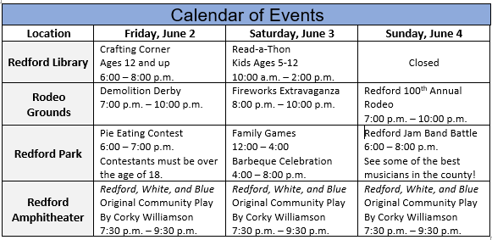  Look at the example below right. Make the table look exactly like that. To save you time, you can copy and paste the middle section from below left. Make the title “Calendar of Events” the same font you used for Redford City and make it larger.
 | Crafting Corner  Ages 12 and up  6:00 – 8:00 p.m. |  | Read-a-Thon  Kids Ages 5-12  10:00 a.m. – 2:00 p.m. | Closed
 | Demolition Derby  7:00 p.m. – 10:00 p.m. |  | Fireworks Extravaganza  8:00 p.m. – 10:00 p.m. | Redford 100th Annual Rodeo  7:00 p.m. – 10:00 p.m.
 | Pie Eating Contest  6:00 – 7:00 p.m.  Contestants must be over the age of 18. |  | Family Games  12:00 – 4:00  Barbeque Celebration  4:00 – 8:00 p.m. | Redford Jam Band Battle  6:00 – 8:00 p.m.  See some of the best musicians in the county!
 | Redford, White, and Blue  Original Community Play  By Corky Williamson  7:30 p.m. – 9:30 p.m. |  | Redford, White, and Blue  Original Community Play  By Corky Williamson  7:30 p.m. – 9:30 p.m. | Redford, White, and Blue  Original Community Play  By Corky Williamson  7:30 p.m. – 9:30 p.m.

☐ | Make sure to set your shading the same—blue on the title and light gray on the first column.
☐ | Center Alignment – Select the first column with the locations and bold it, then center align it.
☐ | Word Art – Create WordArt that says “Family Game Activities.” Match it to your Redford font and place it next to the calendar of events. (See example at the bottom of this assignment for help) Change the font to between 16 and 20. Whichever looks best.
☐ | SmartArt – From the List section of SmartArt, choose Horizontal Bulleted List. | 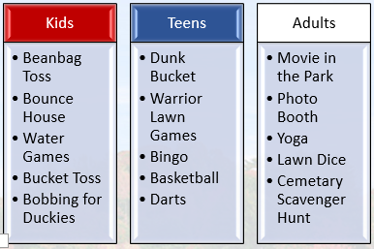
☐ | Wrapping – Change the wrap on the SmartArt to In Front of Text. Then resize it to fit in the space below family Game activities, but no longer than the calendar.
☐ | Make it look like the image to the right. You’ll have to do your own typing this time!
☐ | SmartArt Style – Choose the style Cartoon.
☐ | Edit Styles – Change the top bevel on the bulleted sections to Cross.(Click on the beveled section of your SmartArt, right click, and choose Format Shape. In the Effects section, change the top bevel to cross.
☐ | You may need to change the font size of the bullets to 12 to make it fit easier.
☐ | Change the SmartArt so that it’s right to left—Adults on the left, then teens, then Kids.
☐ | Go to the first blank line after the table and press delete until there is only one blank line between it and the table.
☐ | Columns – Select the whole paragraph and add two columns, with a line between, and .2 spacing. It should all fit on one side.
☐ | Text Box – Insert a Whisp Quote text box. Resize it to be at the bottom of the second column—see the example at the bottom if you are unsure how to place it.
☐ | Cut & Paste – Select the quote at the end of the paragraph that begins with “Here we shall build it” Cut it, and paste it inside the textbox. Make sure to enter ~Archibald Redford in the Cite Source section—make sure your text box isn’t too small or you won’t see it.
☐ | Insert Image – Place your cursor in front of the word “It” at the beginning of the paragraph, and insert the image “Archibald Redford” from your Lesson 2 folder.
☐ | Image Size – Change the size to 1” exactly.
☐ | Image Wrapping – Change the wrap to Square.
☐ | Insert the image “Redford Family” and change the size to 1” exactly.
☐ | Column Break – Go to the end of the word “performance!” and add a column break. This will get you to the second column and add your line between.
☐ | Tabs – Set tabs to first two center tabs for Treats and Souvenirs, and then left and decimal tabs. Make it look exactly like the image below. (Hint: In this case, it might be easier to set the tabs using the ruler so you can see where they are going to be. Take a guess and set them—you can always adjust them after you’ve typed it all in.)  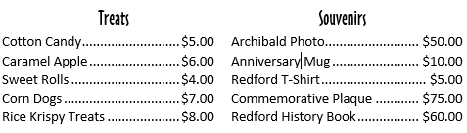
 | Text Effects – Use text effects on Treats and Souvenirs to match the same effects you used for the WordArt in Family Game Activities.
☐ | Wrap – Change the wrap on the text box to In Front of Text and center it better in the remaining space.
☐ | Icons – Go to Icons and search for fireworks, or celebrate. Insert one of them and change the font to In Front of Text, then move it to the left side of “200th Anniversary” title. Change the color to Blue. Insert a second, different firework icon and put it on the right, changing the wrap and making it red.
☐ | In the Calendar of events, choose six icons that fit with the various activities and place them in the calendar, making sure they are in front of text. Keep them black. Look at the example at the bottom for ideas, but you don’t have to do the same images or in the same exact places.
☐ | Print – Make sure it fits on one page before printing. Most likely the background you inserted will not show when you go to the print preview. If that is the case, go to File, Options, Display and check the box that says “Print Background colors and images.” Then Print.
