

**Thanksgiving**

**Keyboarding**

**Packet**

**Activity 1 – MISSING VOWELS LIST**

**Directions**: Key the following words in a numbered list filling in the missing vowels. Save as Activity 1 in your Thanksgiving folder.

1. Br⚫⚫d
2. C⚫rv⚫
3. Y⚫m
4. Gr⚫vy
5. C⚫rn
6. C:\Users\Lenovo User\AppData\Local\Microsoft\Windows\Temporary Internet Files\Content.IE5\92R9CMLR\MC900155378[1].wmfH⚫l⚫d⚫y
7. B⚫k⚫
8. Fr⚫⚫t
9. C⚫⚫k
10. T⚫rk⚫y
11. Dr⚫ss⚫ng
12. F⚫⚫st
13. F⚫ll
14. P⚫r⚫d⚫
15. P⚫mpk⚫n
16. V⚫g⚫t⚫bl⚫s
17. ⚫⚫t
18. N⚫v⚫mb⚫r
19. F⚫m⚫ly
20. H⚫rv⚫st
21. Ch⚫n⚫
22. F⚫⚫tb⚫ll
23. ⚫ct⚫b⚫r
24. ⚫⚫t⚫mn
25. Th⚫nkf⚫l
26. F⚫⚫d
27. St⚫ff⚫ng
28. G⚫bbl⚫
29. P⚫⚫
30. D⚫nn⚫r

Activity 2 – FIND & REPLACE

Directions: Open Thanksgiving Find & Replace document from [www.r5business.weebly.com](http://www.r5business.weebly.com). Using the find and replace feature in Microsoft Word solve the Thanksgiving words. Save to your U:drive as Activity 2.

|  |  |
| --- | --- |
| FIND | REPLACE |
| 15 | A |
| 13 | B |
| 11 | C |
| 42 | D |
| 26 | E |
| 23 | F |
| 18 | G |
| 16 | H |
| 19 | I |
| 21 | J |
| 24 | K |
| 43 | L |
| 46 | M |
| 20 | N |
| 12 | O |
| 48 | P |
| 25 | Q |
| 17 | R |
| 45 | S |
| 22 | T |
| 47 | U |
| 14 | V |
| 41 | W |
| 49 | X |
| 10 | Y |
| 44 | Z |

Activity 3 – INTERNET HUNT

Directions: Use an Internet search engine, answer the questions below. Type the question and your answer.

Save as Activity 3

1. Which one of our forefathers wanted the turkey instead of the bald eagle as the national symbol?
2. What state consumes the most turkey per person?
3. Who encouraged Abraham Lincoln to create Thanksgiving Day in 1863?
4. Can domestic turkeys fly?
5. What three states were the leading producers of turkey in 2011?
6. How many feathers does a mature turkey have?
7. Who sponsors the annual Thanksgiving Day Parade in New York City?
8. Where was the first Thanks Day Parade held in 1920?
9. Thanksgiving Day is celebrated in Canada on the second Monday in October. What United States holiday falls on that day?
10. How many days does it take for a turkey egg to hatch?



Activity 4 – KEYBOARDING HISTORY

**Directions:** Type the following passage and then answer the questions using the following formatting:

* Title and paragraph in **Courier New, 10 point**
* Type the 1-8 answers in complete sentences. Number your responses.
* Save as: Activity 4 in your Thanksgiving folder.

CHEYENNE

The Cheyenne Native American Tribe is pronounced ‘Shy-ANN’. This tribe calls themselves Tsitsistas, which translates “the people.” Originally residents of Minnesota, they migrated as far west as the Dakotas, Wyoming, and Colorado. During the late 1800’s, many members of the Cheyenne Tribe were coerced to Oklahoma by the United States government. During that time, some members fled north to Montana. Members of the Cheyenne tribe today live in one of two tribes in Montana or Oklahoma.

Many native American tribes in the United States are autonomous, which means each tribe has its own laws, judicial system, and government. However, only the Northern Cheyenne have their own legally owned land totally under their control. Harmony is a characteristic valued by this tribe and consensus is required by council members when decision making.

1. What does the Cheyenne tribe call themselves?

2. Where did the Cheyenne tribe originate?

3. When were the Cheyenne forced out of their homeland?

4. During the 1800’s, some tribe members fled to Montana. True or False

5. Many American tribes are autonomous. True or False

6. Identify the human trait important to the Cheyenne.

7. Using your mouse, drag the word consensus, right click, and identify one

of its synonym’s.

8. How many Cheyenne tribes exist today?

Activity 5 – WORDS

Directions: Find 30 words using the letters in HAPPY THANKSGIVING. Save as Activity 5 in your Thanksgiving folder.

Use the following to format your words:

|  |  |
| --- | --- |
| Words that begin with A – H | Centered, Britannic Bold, 13 point |
| Words that begin with I – Q | Left Aligned, *Italic*, Calibri, 14 point |
| Words that begin with R – Z | Right Aligned, Underlined, Chiller, 15 point |

HAPPY

THANKSGIVING

C:\Users\Lenovo User\AppData\Local\Microsoft\Windows\Temporary Internet Files\Content.IE5\5K5OVTY7\MC900412722[1].wmf

Activity 6 – RECIPE

Directions: Type the following recipe for Pumpkin Pie formatting it in an attractive way. Find a picture of pumpkin pie and insert it into the document. Save as Activity 6 in your Thanksgiving folder.

**Homemade pumpkin pie**

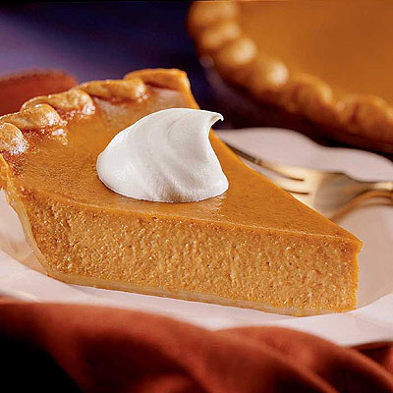**Ingredients:**

|  |
| --- |
| 2 2/3 cups all-purpose flour  1 teaspoon salt  1 cup shortening  1/2 cup cold water  2 cups mashed, cooked pumpkin  1 (12 fluid ounce) can evaporated milk2 eggs, beaten  3/4 cup packed brown sugar  1/2 teaspoon ground cinnamon  1/2 teaspoon ground ginger  1/2 teaspoon ground nutmeg  1/2 teaspoon salt |

**Directions:**

|  |  |
| --- | --- |
| **1.** | Preheat oven to 400 degrees F (200 degrees C). |
| **2.** | Prepare pie crust by mixing together the flour and salt. Cut shortening into flour, add 1 tablespoon water to mixture at a time. Mix dough and repeat until dough is moist enough to hold together. |
| **3.** | With lightly floured hands shape dough into a ball. On a lightly floured board roll dough out to 1/8 inch thickness. With a sharp knife, cut dough 1 1/2 inch larger than the upside down 8 to 9 inch pie pan. Gently roll the dough around the rolling pin and transfer it right side up on to the pie pan. Unroll, ease dough into the bottom of the pie pan. |
| **4.** | In a large bowl with mixer speed on medium, beat pumpkin with evaporated milk, eggs, brown sugar, cinnamon, ginger, nutmeg and salt. Mix well. Pour into a prepared crust. Bake 40 minutes or until when a knife is inserted 1 inch from the edge comes out clean. |

Activity 7 – I AM THANKFUL FOR…

**Directions:** Answer each question. Try not to answer the same answer more than one time. Type the question in ARIAL font and your answer in the font of your choice other than Arial. Save as Activity 7 to your Thanksgiving folder.

1. What are you thankful that is green?
2. What are thankful for that is yellow?
3. What are you thankful for that is soft?
4. What are you thankful for that is round?
5. What are you thankful for that is very small?
6. What are you thankful for that is very big?
7. What are you thankful for that that tastes good?
8. What are you thankful for that tastes bad?
9. What are you thankful for that you cannot see?
10. What are you thankful for that you cannot touch?
11. What do you think your teacher is thankful for?
12. What do you think a teenager is thankful for?
13. What do you think a very old person is thankful for?
14. What do you think the president is thankful for?
15. What do you think a dog is thankful for?
16. What do you think a cat is thankful for?

Write your own thankful question and then answer it.

Activity 8 – DECODER ACTIVITY

Directions: Use the table below to decode the Thanksgiving words. Type your answers in a numbered list. Save as Activity 8 in your Thanksgiving folder.

|  |  |  |  |  |  |  |  |  |  |  |  |  |  |  |  |  |  |  |  |  |  |  |  |  |  |
| --- | --- | --- | --- | --- | --- | --- | --- | --- | --- | --- | --- | --- | --- | --- | --- | --- | --- | --- | --- | --- | --- | --- | --- | --- | --- |
| A | B | C | D | E | F | G | H | I | J | K | L | M | N | O | P | Q | R | S | T | U | V | W | X | Y | Z |
| 15 | 13 | 11 | 2 | 26 | 23 | 18 | 16 | 19 | 21 | 24 | 3 | 6 | 20 | 12 | 8 | 25 | 17 | 5 | 22 | 7 | 14 | 1 | 9 | 10 | 4 |

1. 5-22-7-23-23-19-20-18
2. 11-12-17-20
3. 20-12-14-26-6-13-26-17
4. 8-19-26
5. 23-12-12-2
6. 13-17-26-15-2
7. 11-16-19-20-15
8. 23-15-3-3
9. 2-17-26-5-5-19-20-18
10. 16-12-3-19-2-15-10
11. 15-7-22-7-6-20
12. 23-17-7-19-22
13. 22-7-17-24-26-10
14. 18-12-13-13-3-26
15. 18-17-15-14-10
16. 8-15-17-15-2-26
17. 11-12-12-24
18. 12-11-22-12-13-26-17
19. 2-19-20-20-26-17
20. 26-15-22
21. 16-15-17-14-26-5-22
22. 23-26-15-5-22
23. 22-16-15-20-24-23-7-3
24. 23-12-12-22-13-15-3-3
25. 8-7-6-24-19-20
26. 14-26-18-26-22-15-13-3-26-5
27. 13-15-24-26
28. 23-15-6-19-3-10
29. 10-15-6
30. 11-15-17-14-26

Activity 9 – ACROSTIC POEM

**Directions:** Create an acrostic poem using the word THANKFUL. Use WordArt, textboxes and colorful text to make your poem attractive.

**echnology**

T

H

A

N

K

F

U

L

C:\Users\Lenovo User\AppData\Local\Microsoft\Windows\Temporary Internet Files\Content.IE5\B9FBTQB2\MC900412714[1].wmf

ids

isterene

nited States

utella

amily

pple iPhone

eat

Activity 10 – KEYBOARDING HISTORY

**Directions:** Type the following passage and then answer the questions using the following formatting:

* Title and paragraph in **Courier New, 10 point**
* Type the 1-8 answers in complete sentences. Number your responses.
* Save as: Activity 10 in your Thanksgiving folder.

NATIVE AMERICANS

Prior to European arrival in the sixteenth century, about 50 Native American tribes inhabited the northeast regions of what is now the United States and Canada. Dense forests covered the area of their lands extending from the Atlantic Coast to the Mississippi River and southeastern Canada to the area known today as North Carolina and Kentucky. In addition to the thick forest, coastal plains, lakes, mountains, and inland rivers, more than one thousand miles of shoreline existed! Many of these early tribes were descendants of the great culture of the Mound Builders who migrated from Asia some 10,000 years prior and became established along the Mississippi and Ohio Rivers.

1. When did European settlers arrive in what is now North America?

2. Approximately _______________ Native American groups lived in the

area now considered the United States.

3. What two words are used interchangeably to describe the forest?

________________________ & _______________________

4. Describe at least three land forms that were present during the

sixteenth century. __________________, __________________, & ________________.

5. The Native American tribes referred to in this passage inhabited the northeast

regions of what is now known as the United States. True OR False????

6. What coast line is referred to in the passage?

A. Indian B. Pacific C. Mediterranean D. Atlantic

7. Of what culture did many of the tribes of the sixteenth century descend?

8. The Mound Builders descended from _________________________ about 10,000 years

prior to the sixteenth century.

Activity 11 – TYPING PUZZLE

Typing Mystery

Use the Typing Mystery document to start or use the following settings:

* + Use the NO SPACING Quick Style
  + Set your left margin to 2.5” (Page Layout, Margins, Custom Margins)
  + Set your font to “Courier New”, size 12
  + Type only capital M
  + Select all text and center vertically
  + Add WordArt, “Happy Thanksgiving” above the image.

1. 27sp 3M
2. 22sp 9M
3. 19sp 16M
4. 5sp 5M 9sp 16M
5. 3sp 8M 7sp 20M
6. 1sp 10M 6sp 22M
7. 11M 6sp 21M
8. 2sp 9M 6sp 22M
9. 2sp 38M
10. 3sp 36M
11. 2sp 37M
12. 1sp 39M
13. 2sp 37M
14. 3sp 35M
15. 4sp 33M
16. 4sp 31M
17. 7sp 26M
18. 9sp 23M
19. 12sp 8M 3sp 6M
20. 11sp 8M
21. 10sp 8M
22. 9sp 9M
23. 10sp 8M

Activity 12 – WORDSEARCH

**Directions:**  Open the document from r5business.weebly.com named WORDSEARCH. Using the highlighting option complete the word search. Save the highlighted word search as Activity 12 in your Thanksgiving folder.

|  |  |  |  |  |  |  |  |  |  |  |  |  |  |  |
| --- | --- | --- | --- | --- | --- | --- | --- | --- | --- | --- | --- | --- | --- | --- |
| C | L | U | F | K | N | A | H | T | L | F | E | A | S | T |
| J | E | I | T | Q | Z | K | T | Z | W | O | P | Q | E | W |
| Z | M | U | U | F | G | P | I | L | G | R | I | M | S | N |
| K | J | C | R | Y | G | C | T | W | V | L | F | Y | I | C |
| S | R | G | K | I | M | D | O | N | D | T | D | K | E | R |
| T | H | I | E | Z | B | L | O | D | S | I | P | L | U | K |
| U | N | P | Y | E | C | V | F | E | L | M | E | G | V | G |
| F | O | T | I | H | E | F | V | Z | U | B | F | R | M | I |
| F | P | P | Y | M | V | R | X | P | R | Y | Z | E | F | Q |
| I | Y | R | B | U | A | E | Z | A | Z | L | Q | N | T | J |
| N | M | E | Q | H | W | R | R | H | I | I | B | N | U | T |
| G | R | Q | Q | U | Y | E | O | D | K | M | A | I | Y | J |
| V | W | Z | S | U | D | H | R | D | D | A | F | D | G | L |
| I | F | L | Z | D | B | L | B | P | I | F | S | H | T | Z |
| Z | E | K | B | E | E | J | M | H | V | Q | N | W | C | P |

celebrate

November

thankful

dinner

pie

turkey

family

pilgrims

feast

pumpkin

harvest

stuffing

Activity 13 – TURKEY DRAW

**Directions:**  Using shapes create a turkey similar to the one below. Name your turkey using WordArt.

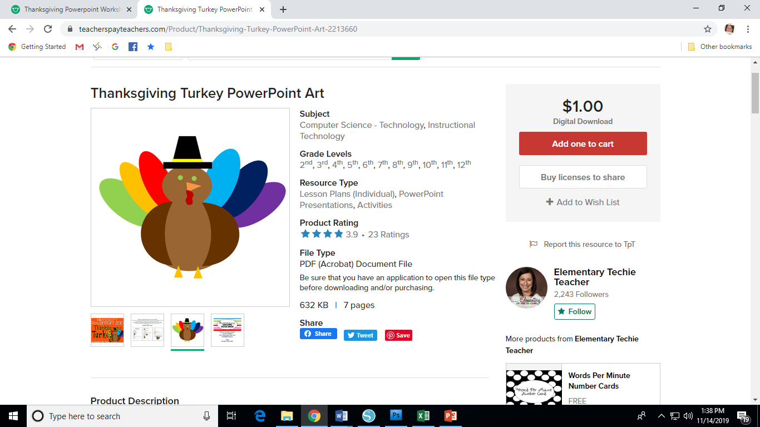

**Thanksgiving**

**Keyboarding**

**Packet**

**Name:____________________________ Computer:_________**

**_____ Activity 1 Missing Vowels List**

**_____ Activity 2 Find & Replace**

**_____ Activity 3 Internet Hunt**

**_____ Activity 4 Keyboarding History**

**_____ Activity 5 Words**

**_____ Activity 6 Recipe \***

**_____ Activity 7 I Am Thankful For…\***

**_____ Activity 8 Decoder Activity**

**_____ Activity 9 Acrostic Poem \***

**_____ Activity 10 Keyboarding History**

**_____ Activity 11 Typing Puzzle**

**_____ Activity 12 Digital Word Search**

**_____ Activity 13 Turkey Draw \***

**\*Print and attach to this sheet.**